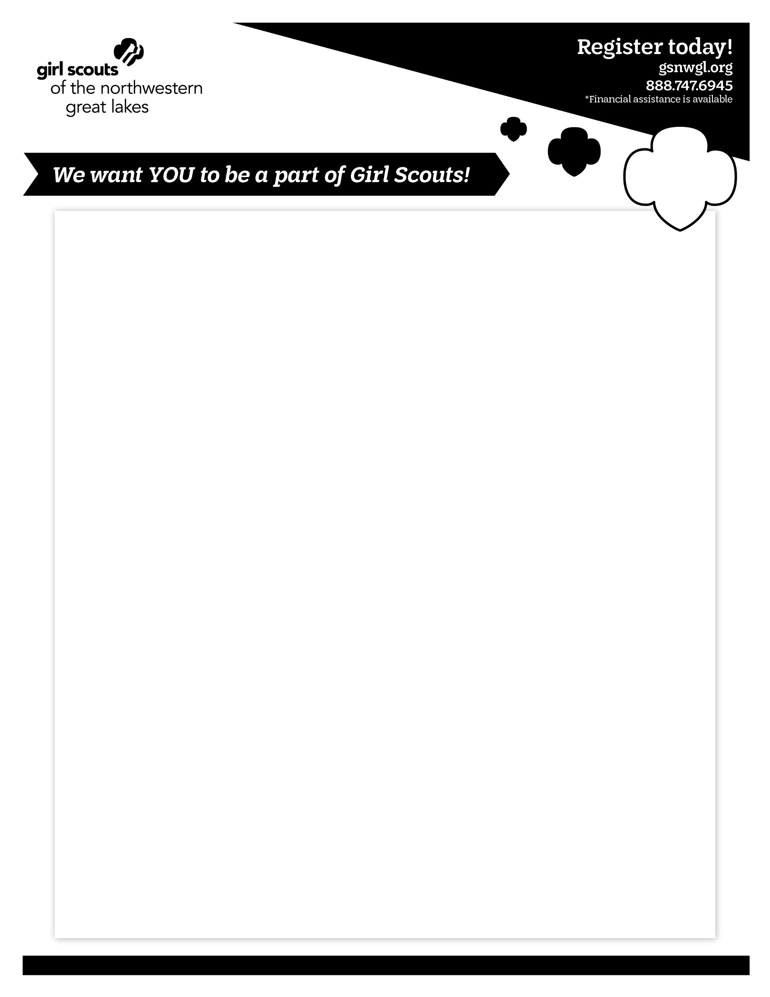

**GIRL SCOUTS**

**Fall is just around the corner and troops will be starting soon!**

**Join us for an ICE CREAM SOCIAL with activities for the girls!**

**Girl Scouts will be there to answer questions.**

**Date: Tuesday, September 24th**

**Time: 5:30-7:00 PM come anytime during this time**

**Location: Irvine Park Activity Building**

***Membership Engagement Coordinator Contact: Renee Erickson | rerickson@gsnwgl.org | 920.955.3428***

*Financial Assistance available for Membership and Uniforms.*

***Disclaimer of the Chippewa Falls Area Unified School District.***

*The Chippewa Falls Area Unified School District from time to time permits the distribution of information about appropriate non-commercial activities sponsored by organizations. The fact that this information is distributed through the Chippewa Falls Area Unified School District does not mean or imply sponsorship of, or support of, the activity by the school system. Any problems related to the operation of the activity will be strictly between the participant and the sponsoring organization. Request for further information about the activity should be directed to the sponsoring organization.*

Insert text here, using Trefoil Sans or Arial font.